PMCA503P DATABASE SYSTEM LAB
CYCLE SHEET – 1

Consider the following relational database schema for teaching-learning process in a university.
(Source: Database Systems – Coronel & Morris)

PROFESSOR(Prof_id, Prof_name, Email, Mobile, Specialty, Dept_id)
SCHOOL(SCode, Scl_name, Prof_id, Location)
DEPARTMENT(Dept_id, Dname, SCode, Prof_id)
COURSE(Crs_code, Crs_name, Description, Credits, Hours)
CLASS(Cls_code, Slot, Stime, Etime, Crs_code, Prof_id, Room_no, Sem_code, Day_of_week)
SEMESTER(Sem_code, Term, Year, Sdate, Edate)
STUDENT(Reg_no, Sname, Address, DoB, Email, Mobile, Dept_id, Prof_id)
ENROLL(Cls_code, Reg_no, Enroll_time, Grade)
STUDENT_VISA(Reg_no, Visa_status)
PROGRAMME(Prog_code, Prog_name, Prog_preamble, Scode, Dept_id)

The primary keys are underlined and foreign keys are self-explanatory. The Dept_id column in
professor table stands for the department the professor belongs to and Prof_id column in the
school table stands for the professor who chairs the school, the same column in the department
table stands for the professor who heads the department, the domain of Term column in semester
table is {Winter, Fall}

Q1. Create the above tables.
Q2. Enter data into the above tables. (Learn how to enter data interactively also.). Display the
content of each table. Use column formatting while displaying.
-- TABLES
create table PROFESSOR(Prof_id char(5), Prof_name varchar(20), Email varchar(25), Mobile varchar(10), Speciality varchar(12), Dept_id varchar(5));
create table SCHOOL(SCode varchar(5), Scl_name varchar(20), Prof_id char(5), Location varchar(15));
create table DEPARTMENT(Dept_id varchar(5), Dname varchar(15), SCode varchar(7), Prof_id char(5));
create table COURSE(Crs_code varchar(5), Crs_name varchar(18), Description varchar(30), Credits number(2), Hours number(3));
create table CLASS(Cls_code varchar(21), Slot varchar(10), Stime timestamp, Etime timestamp, Crs_code varchar(5), Prof_id char(5), Room_no number(3), Sem_code varchar(8), Day_of_week varchar(7));
create table SEMESTER(Sem_code varchar(7), Term varchar(6), Year varchar(7), Sdate date, Edate date);
create table STUDENT(Reg_no varchar(11), Sname varchar(15), Address varchar(25), DoB date, Email varchar(25), Mobile varchar(10), Dept_id varchar(5), Prof_id char(5));
create table ENROLL(Cls_code varchar(12), Reg_no varchar(11), Enroll_time timestamp, Grade char(1));
create table STUDENT_VISA(Reg_no varchar(11), Visa_status varchar(10));
create table PROGRAMME(Prog_code varchar(5), Prog_name varchar(10), Prog_preamble varchar(40), Scode varchar(5), Dept_id varchar(5));

-- Q3 Alter or Recreate the above tables with primary key and foreign key and the following
integrity constraints assigning name to integrity constraint
-- PRIMARY KEYS
alter table PROFESSOR add constraint prof_id_pk primary key(Prof_id);
alter table SCHOOL add constraint scode_pk primary key(SCode);
alter table DEPARTMENT add constraint dept_id_pk primary key(Dept_id);
alter table COURSE add constraint crs_code_pk primary key(Scode);
alter table CLASS add constraint cls_code_pk primary key(Cls_code);
alter table SEMESTER add constraint sem_code_pk primary key(Sem_code);
alter table STUDENT add constraint reg_no_pk primary key(Reg_no);
alter table ENROLL add constraint cls_n_reg_no_pk primary key(Cls_code, Reg_no);
alter table STUDENT_VISA add constraint sv_reg_no_pk primary key(Reg_no);
alter table PROGRAMME add constraint prog_code_pk primary key(Prog_code);

-- FOREIGN KEY
alter table PROFESSOR add constraint fk_professor_dept_id foreign key (Dept_id) refrences DEPARTMENT(Dept_id) deferrable initially deferred;

alter table SCHOOL add constraint sc_p_id_fk foreign key(Prof_id) refrences PROFESSOR(Prof_id);

alter table DEPARTMENT add constraint dept_SCode_fk foreign key(SCode) refrences SCHOOL(SCode);
alter table DEPARTMENT add constraint dept_p_id_fk foreign key(Prof_id) refrences PROFESSOR(Prof_id) deferrable initially deferred;

alter table CLASS add constraint cl_p_id_fk foreign key(Prof_id) refrences PROFESSOR(Prof_id);
alter table CLASS add constraint cl_sem_code_fk foreign key(Sem_code) refrences SEMESTER(Sem_Code);
alter table CLASS add constraint cl_crs_code_fk foreign key(Crs_code) refrences COURSE(Crs_code);

alter table STUDENT add constraint stu_p_id_fk foreign key(Prof_id) refrences PROFESSOR(Prof_id);
alter table STUDENT add constraint stu_dept_id_fk foreign key(Dept_id) refrences DEPARTMENT(Dept_id) deferrable initially deferred;

alter table ENROLL add constraint en_cls_code_fk foreign key(Cls_code) refrences CLASS(Cls_code);
alter table ENROLL add constraint en_reg_no_fk foreign key(Reg_no) refrences STUDENT(Reg_no);

alter table STUDENT_VISA add constraint sv_reg_no_fk foreign key(Reg_no) refrences STUDENT(Reg_no);

alter table PROGRAMME add constraint prog_dept_id_fk foreign key(Dept_id) refrences DEPARTMENT(Dept_id);
alter table PROGRAMME add constraint prog_SCode_fk foreign key(Scode) refrences SCHOOL(SCode);

--i) Prof_id must have exactly five characters and their email and mobile number are unique. The email address must have @ as one of the characters and mobile number must have exactly ten characters.
alter table PROFESSOR add constraint pf_id_ck check(length(Prof_id)=5);
alter table PROFESSOR add constraint pf_email_ck check(Email like '%@%');
alter table PROFESSOR add constraint pf_mobile_len check(length(Mobile)=10);
alter table PROFESSOR add constraint pf_mobile_unq UNIQUE(Mobile);

--ii) Use timestamp data type without fractional parts of seconds for start time and end time column of class table.
alter table CLASS add constraint stime_ck check(EXTRACT(MILLISECOND FROM Stime)=0);
alter table CLASS add constraint etime_ck check(EXTRACT(MILLISECOND FROM Etime)=0);

--iii) The Sem_code should start with either ‘Win’ or ‘Fall’ and Term column can assume only one of two values {Winter, Fall}.
alter table SEMESTER add constraint sem_code_ck check(Sem_code like 'Win%' or Sem_code like 'Fall%');
alter table SEMESTER add constraint term_ck check(Term in ('Winter', 'Fall'));

--iv) Email and mobile column in student table should have same characteristics as those in professor table.
alter table STUDENT add constraint st_email_ck check(Email like '%@%');
alter table STUDENT add constraint st_mobile_len check(length(Mobile)=10);
alter table STUDENT add constraint st_mobile_unq UNIQUE(Mobile);

--v) The enroll_time in the enroll table should be of timestamp data type without fractional parts of seconds. The grade may assume one of the values in {‘S’, ‘A’, ‘B’, ‘C’, ‘D’}
alter table ENROLL add constraint grade_ck check(Grade in ('S', 'A', 'B', 'C', 'D'));

--Insert
INSERT INTO PROFESSOR VALUES ('PMT01', 'Albert Smith', 'albert@uni.edu', '9876543210','Maths' , 'DEPMT');
INSERT INTO PROFESSOR VALUES ('PMT02', 'Linda R', 'linda.r@uni.edu', '9876003210', 'Maths', 'DEPMT');
INSERT INTO PROFESSOR VALUES ('PPY01', 'Barney Johnson', 'barney.j@uni.edu', NULL, 'Physics', 'DEPPY');
INSERT INTO PROFESSOR VALUES ('PPY02', 'Ted Morsby', 'ted.m@uni.edu', '6547891234', 'Physics', 'DEPPY');
INSERT INTO PROFESSOR VALUES ('PCH01', 'Carl White', 'carl.w@uni.edu', '7654321098', 'Chemistry', 'DEPCH');
INSERT INTO PROFESSOR VALUES ('PCH02', 'David Miller', 'david.m@uni.edu', '9879876543', 'Chemistry', 'DEPCH');
INSERT INTO PROFESSOR VALUES ('PMD01', 'Dave Brown', 'dave.b@uni.edu', NULL, 'Medicine', 'DEPMD');
INSERT INTO PROFESSOR VALUES ('PMD02', 'Ivian Adams', 'ivian.a@uni.edu', '1098765432', 'Medicine', 'DEPMD');
INSERT INTO PROFESSOR VALUES ('PHT01', 'Elsa Green', 'elsa.g@uni.edu', '5432109876','History', 'DEPHT');
INSERT INTO PROFESSOR VALUES ('PHT02', 'Jenny Martin', 'jenny.m@uni.edu', '9087654321', 'History', 'DEPHT');
INSERT INTO PROFESSOR VALUES ('POS01', 'Rakesh Kumar', 'rakesh.k@uni.edu', '8076543210', 'OS', 'DEPOS');
INSERT INTO PROFESSOR VALUES ('POS02', 'Donna Carter', 'donna.c@uni.edu', '6054321098', 'OS', 'DEPOS');
INSERT INTO PROFESSOR VALUES ('PDB01', 'Henry Baker', 'henry.b@uni.edu', '7065432109', 'Database', 'DEPDB');
INSERT INTO PROFESSOR VALUES ('PDB02', 'Sam Wilson', 'sam.w@uni.edu', '5043210987', 'Database', 'DEPDB');
INSERT INTO PROFESSOR VALUES ('PDB03', 'Lily Scott', 'lily.s@uni.edu', '4032109876', 'Database', 'DEPDB');

INSERT INTO SCHOOL VALUES ('SCSCI', 'Science School', 'PCH02', 'Science Block');
INSERT INTO SCHOOL VALUES ('SCMED', 'Medicine School', 'PPY02', 'Medicine Block');
INSERT INTO SCHOOL VALUES ('SCART', 'Arts School', 'PHT02', 'Arts Block');
INSERT INTO SCHOOL VALUES ('SCTEC', 'Tech School', 'PDB02', 'Tech Block');

INSERT INTO DEPARTMENT VALUES ('DEPMT', 'Math Dept', 'SCSCI', 'PMT01');
INSERT INTO DEPARTMENT VALUES ('DEPPY', 'Physics Dept', 'SCSCI', 'PPY01');
INSERT INTO DEPARTMENT VALUES ('DEPCH', 'Chemistry Dept', 'SCSCI', 'PCH01');
INSERT INTO DEPARTMENT VALUES ('DEPMD', 'Medicine Dept', 'SCMED', 'PMD01');
INSERT INTO DEPARTMENT VALUES ('DEPHT', 'History Dept', 'SCART', 'PHT01');
INSERT INTO DEPARTMENT VALUES ('DEPOS', 'OS Dept', 'SCTEC', 'POS01');
INSERT INTO DEPARTMENT VALUES ('DEPDB', 'Database Dept', 'SCTEC', 'PDB01');

INSERT INTO COURSE VALUES ('CRMT1', 'Intro to Math', 'Basic concepts of mathematics', 4, 40);
INSERT INTO COURSE VALUES ('CRPY1', 'Basic Physics', 'Principles modern physics', 3, 30);
INSERT INTO COURSE VALUES ('CRPY2', 'Advanced Physics', 'Principles modern physics', 4, 40);
INSERT INTO COURSE VALUES ('CRCH1', 'Advanced Chem', 'In-depth study of reactions', 4, 40);
INSERT INTO COURSE VALUES ('CRBI1', 'Bio Research', 'Techniques for Bio research', 4, 40);
INSERT INTO COURSE VALUES ('CRHT1', 'Ancient History', 'Methods of historical research', 4, 40);
INSERT INTO COURSE VALUES ('CROS1', 'Operating Systems', 'Understanding OS', 4, 40);
INSERT INTO COURSE VALUES ('CRDB1', 'Database System', 'Methods of DBMS', 4, 40);
INSERT INTO COURSE VALUES ('CRDB2', 'Database Basics', 'Basics of DBMS', 3, 30);

INSERT INTO SEMESTER VALUES ('FAL1617', 'Fall', '2016', TO_DATE('2016-07-01', 'YYYY-MM-DD'), TO_DATE('2016-11-15', 'YYYY-MM-DD'));
INSERT INTO SEMESTER VALUES ('WIN1617', 'Winter', '2016', TO_DATE('2016-12-15', 'YYYY-MM-DD'), TO_DATE('2017-05-15', 'YYYY-MM-DD'));
INSERT INTO SEMESTER VALUES ('FAL1718', 'Fall', '2017', TO_DATE('2017-07-01', 'YYYY-MM-DD'), TO_DATE('2017-11-15', 'YYYY-MM-DD'));
INSERT INTO SEMESTER VALUES ('WIN1718', 'Winter', '2017', TO_DATE('2017-12-15', 'YYYY-MM-DD'), TO_DATE('2018-05-15', 'YYYY-MM-DD'));

-- Fall 2016 Semester
INSERT INTO CLASS VALUES ('ClsFMat16MWF', 'Morning', TO_TIMESTAMP('09:00:00', 'HH24:MI:SS'), TO_TIMESTAMP('10:30:00', 'HH24:MI:SS'), 'CRMT1', 'PMT01', 101, 'FAL1617', 'MWF');
INSERT INTO CLASS VALUES ('ClsFPhy16TTh', 'Afternoon', TO_TIMESTAMP('14:00:00', 'HH24:MI:SS'), TO_TIMESTAMP('15:30:00', 'HH24:MI:SS'), 'CRHT1', 'PPY01', 102, 'FAL1617', 'TTh');
INSERT INTO CLASS VALUES ('ClsFChe16MWF', 'Evening', TO_TIMESTAMP('17:00:00', 'HH24:MI:SS'), TO_TIMESTAMP('18:30:00', 'HH24:MI:SS'), 'CRCH1', 'PCH01', 103, 'FAL1617', 'MWF');
INSERT INTO CLASS VALUES ('ClsFBio16TTh', 'Morning', TO_TIMESTAMP('08:00:00', 'HH24:MI:SS'), TO_TIMESTAMP('09:30:00', 'HH24:MI:SS'), 'CRBI1', 'PMD01', 104, 'FAL1617', 'TTh');
INSERT INTO CLASS VALUES ('ClsFHis16MWF', 'Afternoon', TO_TIMESTAMP('13:00:00', 'HH24:MI:SS'), TO_TIMESTAMP('14:30:00', 'HH24:MI:SS'), 'CRHT1', 'PHT01', 105, 'FAL1617', 'MWF');
INSERT INTO CLASS VALUES ('ClsF0OS16MWF', 'Evening', TO_TIMESTAMP('16:00:00', 'HH24:MI:SS'), TO_TIMESTAMP('17:30:00', 'HH24:MI:SS'), 'CROS1', 'POS01', 106, 'FAL1617', 'MWF');
INSERT INTO CLASS VALUES ('ClsF0DB16TTh', 'Morning', TO_TIMESTAMP('10:00:00', 'HH24:MI:SS'), TO_TIMESTAMP('11:30:00', 'HH24:MI:SS'), 'CRDB1', 'PDB03', 107, 'FAL1617', 'TTh');
INSERT INTO CLASS VALUES ('ClsFDBB16MWF', 'Afternoon', TO_TIMESTAMP('14:00:00', 'HH24:MI:SS'), TO_TIMESTAMP('15:30:00', 'HH24:MI:SS'), 'CRDB2', 'PDB03', 108, 'FAL1617', 'MWF');
-- Winter 2016 Semester
INSERT INTO CLASS VALUES ('ClsWMat16MWF', 'Morning', TO_TIMESTAMP('09:00:00', 'HH24:MI:SS'), TO_TIMESTAMP('10:30:00', 'HH24:MI:SS'), 'CRMT1', 'PMT02', 201, 'WIN1617', 'MWF');
INSERT INTO CLASS VALUES ('ClsWPhy16TTh', 'Afternoon', TO_TIMESTAMP('14:00:00', 'HH24:MI:SS'), TO_TIMESTAMP('15:30:00', 'HH24:MI:SS'), 'CRHT1', 'PPY02', 202, 'WIN1617', 'TTh');
INSERT INTO CLASS VALUES ('ClsWChe16MWF', 'Evening', TO_TIMESTAMP('17:00:00', 'HH24:MI:SS'), TO_TIMESTAMP('18:30:00', 'HH24:MI:SS'), 'CRCH1', 'PCH02', 203, 'WIN1617', 'MWF');
INSERT INTO CLASS VALUES ('ClsWBio16TTh', 'Morning', TO_TIMESTAMP('08:00:00', 'HH24:MI:SS'), TO_TIMESTAMP('09:30:00', 'HH24:MI:SS'), 'CRBI1', 'PMD02', 204, 'WIN1617', 'TTh');
INSERT INTO CLASS VALUES ('ClsWHis16MWF', 'Afternoon', TO_TIMESTAMP('13:00:00', 'HH24:MI:SS'), TO_TIMESTAMP('14:30:00', 'HH24:MI:SS'), 'CRHT1', 'PHT02', 205, 'WIN1617', 'MWF');
INSERT INTO CLASS VALUES ('ClsW0OS16MWF', 'Evening', TO_TIMESTAMP('16:00:00', 'HH24:MI:SS'), TO_TIMESTAMP('17:30:00', 'HH24:MI:SS'), 'CROS1', 'POS02', 206, 'WIN1617', 'MWF');
INSERT INTO CLASS VALUES ('ClsW0DB16TTh', 'Morning', TO_TIMESTAMP('10:00:00', 'HH24:MI:SS'), TO_TIMESTAMP('11:30:00', 'HH24:MI:SS'), 'CRDB1', 'PDB03', 207, 'WIN1617', 'TTh');
INSERT INTO CLASS VALUES ('ClsWDBB16MWF', 'Afternoon', TO_TIMESTAMP('14:00:00', 'HH24:MI:SS'), TO_TIMESTAMP('15:30:00', 'HH24:MI:SS'), 'CRDB2', 'PDB03', 208, 'WIN1617', 'MWF');
-- Fall 2017 Semester
INSERT INTO CLASS VALUES ('ClsFMat17MWF', 'Morning', TO_TIMESTAMP('09:00:00', 'HH24:MI:SS'), TO_TIMESTAMP('10:30:00', 'HH24:MI:SS'), 'CRMT1', 'PMT02', 301, 'FAL1718', 'MWF');
INSERT INTO CLASS VALUES ('ClsFPhy17TTh', 'Afternoon', TO_TIMESTAMP('14:00:00', 'HH24:MI:SS'), TO_TIMESTAMP('15:30:00', 'HH24:MI:SS'), 'CRHT1', 'PPY01', 302, 'FAL1718', 'TTh');
INSERT INTO CLASS VALUES ('ClsFChe17MWF', 'Evening', TO_TIMESTAMP('17:00:00', 'HH24:MI:SS'), TO_TIMESTAMP('18:30:00', 'HH24:MI:SS'), 'CRCH1', 'PCH02', 303, 'FAL1718', 'MWF');
INSERT INTO CLASS VALUES ('ClsFBio17TTh', 'Morning', TO_TIMESTAMP('08:00:00', 'HH24:MI:SS'), TO_TIMESTAMP('09:30:00', 'HH24:MI:SS'), 'CRBI1', 'PMD01', 304, 'FAL1718', 'TTh');
INSERT INTO CLASS VALUES ('ClsFHis17MWF', 'Afternoon', TO_TIMESTAMP('13:00:00', 'HH24:MI:SS'), TO_TIMESTAMP('14:30:00', 'HH24:MI:SS'), 'CRHT1', 'PHT02', 305, 'FAL1718', 'MWF');
INSERT INTO CLASS VALUES ('ClsF0OS17MWF', 'Evening', TO_TIMESTAMP('16:00:00', 'HH24:MI:SS'), TO_TIMESTAMP('17:30:00', 'HH24:MI:SS'), 'CROS1', 'POS01', 306, 'FAL1718', 'MWF');
INSERT INTO CLASS VALUES ('ClsF0DB17TTh', 'Morning', TO_TIMESTAMP('10:00:00', 'HH24:MI:SS'), TO_TIMESTAMP('11:30:00', 'HH24:MI:SS'), 'CRDB1', 'PDB01', 307, 'FAL1718', 'TTh');
INSERT INTO CLASS VALUES ('ClsFDBB17MWF', 'Afternoon', TO_TIMESTAMP('14:00:00', 'HH24:MI:SS'), TO_TIMESTAMP('15:30:00', 'HH24:MI:SS'), 'CRDB2', 'PDB03', 308, 'FAL1718', 'MWF');
-- Winter 2017 Semester
INSERT INTO CLASS VALUES ('ClsWMat17MWF', 'Morning', TO_TIMESTAMP('09:00:00', 'HH24:MI:SS'), TO_TIMESTAMP('10:30:00', 'HH24:MI:SS'), 'CRMT1', 'PMT01', 401, 'WIN1718', 'MWF');
INSERT INTO CLASS VALUES ('ClsWPhy17TTh', 'Afternoon', TO_TIMESTAMP('14:00:00', 'HH24:MI:SS'), TO_TIMESTAMP('15:30:00', 'HH24:MI:SS'), 'CRHT1', 'PPY02', 402, 'WIN1718', 'TTh');
INSERT INTO CLASS VALUES ('ClsWChe17MWF', 'Evening', TO_TIMESTAMP('17:00:00', 'HH24:MI:SS'), TO_TIMESTAMP('18:30:00', 'HH24:MI:SS'), 'CRCH1', 'PCH01', 403, 'WIN1718', 'MWF');
INSERT INTO CLASS VALUES ('ClsWBio17TTh', 'Morning', TO_TIMESTAMP('08:00:00', 'HH24:MI:SS'), TO_TIMESTAMP('09:30:00', 'HH24:MI:SS'), 'CRBI1', 'PMD02', 404, 'WIN1718', 'TTh');
INSERT INTO CLASS VALUES ('ClsWHis17MWF', 'Afternoon', TO_TIMESTAMP('13:00:00', 'HH24:MI:SS'), TO_TIMESTAMP('14:30:00', 'HH24:MI:SS'), 'CRHT1', 'PHT02', 305, 'WIN1718', 'MWF');
INSERT INTO CLASS VALUES ('ClsW0OS17MWF', 'Evening', TO_TIMESTAMP('16:00:00', 'HH24:MI:SS'), TO_TIMESTAMP('17:30:00', 'HH24:MI:SS'), 'CROS1', 'POS01', 306, 'WIN1718', 'MWF');
INSERT INTO CLASS VALUES ('ClsW0DB17TTh', 'Morning', TO_TIMESTAMP('10:00:00', 'HH24:MI:SS'), TO_TIMESTAMP('11:30:00', 'HH24:MI:SS'), 'CRDB1', 'PDB01', 307, 'WIN1718', 'TTh');
INSERT INTO CLASS VALUES ('ClsWDBB17MWF', 'Afternoon', TO_TIMESTAMP('14:00:00', 'HH24:MI:SS'), TO_TIMESTAMP('15:30:00', 'HH24:MI:SS'), 'CRDB2', 'PDB03', 308, 'WIN1718', 'MWF');

-- For 2016
INSERT INTO STUDENT VALUES ('S16MScM001', 'Sunil Gavaskar', '123 Dadar, Mumbai', TO_DATE('2002-05-15', 'YYYY-MM-DD'), 'sunil.g@uni.in', '9876543210', 'DEPMT', 'PMT01');
INSERT INTO STUDENT VALUES ('S16MScM002', 'Kapil Dev', '789 Sector 15, Chandigarh', TO_DATE('2001-06-15', 'YYYY-MM-DD'), 'kapil.d@uni.in', '9876543211', 'DEPMT', 'PMT02');
INSERT INTO STUDENT VALUES ('S16MScM003', 'Mohinder A', '321 Civil Lines, Delhi', TO_DATE('2002-08-25', 'YYYY-MM-DD'), 'mohinder.a@uni.in', '9876543212', 'DEPMT', 'PMT02');
INSERT INTO STUDENT VALUES ('S16MScP001', 'Dilip V', '456 Colaba, Mumbai', TO_DATE('2003-07-20', 'YYYY-MM-DD'), 'dilip.v@uni.in', '9876543213', 'DEPPY', 'PPY02');
INSERT INTO STUDENT VALUES ('S16MScP002', 'Syed Kirmani', '654 Basavanagudi, Indore', TO_DATE('2002-05-10', 'YYYY-MM-DD'), 'syed.k@uni.in', '9876543214', 'DEPPY', 'PPY02');
INSERT INTO STUDENT VALUES ('S16MScP003', 'Gundappa V', '987 Jayanagar, Bangalore', TO_DATE('2003-09-20', 'YYYY-MM-DD'), 'gundappa.v@uni.in', '9876543215', 'DEPPY', 'PPY01');
INSERT INTO STUDENT VALUES ('S16MScC001', 'Bishan Bedi', '7 Katpadi, Vellore', TO_DATE('2001-03-22', 'YYYY-MM-DD'), 'bishan.b@uni.in', '9876543216', 'DEPCH', 'PCH01');
INSERT INTO STUDENT VALUES ('S16MScC002', 'Madan Lal', '135 Ashok Nagar, Delhi', TO_DATE('2001-11-05', 'YYYY-MM-DD'), 'madan.l@uni.in', '9876543217', 'DEPCH', 'PCH02');
INSERT INTO STUDENT VALUES ('S16MScC003', 'Sandeep Patil', '246 Worli, Mumbai', TO_DATE('2002-07-30', 'YYYY-MM-DD'), 'sandeep.p@uni.in', '9876543218', 'DEPCH', 'PCH01');
INSERT INTO STUDENT VALUES ('S16MMed001', 'Ravi Shastri', 'Tamil Nadu', TO_DATE('2000-12-11', 'YYYY-MM-DD'), 'ravi.s@uni.in', '9876543219', 'DEPMD', 'PMD02');
INSERT INTO STUDENT VALUES ('S16MMed002', 'Kris Srikkanth', '468 Mylapore, Chennai', TO_DATE('2001-02-22', 'YYYY-MM-DD'), 'kris.s@uni.in', '9876543220', 'DEPMD', 'PMD02');
INSERT INTO STUDENT VALUES ('S16MMed003', 'Maninder Singh', '579 Sector 9, Chandigarh', TO_DATE('2000-04-18', 'YYYY-MM-DD'), 'maninder.s@uni.in', '9876543221', 'DEPMD', 'PMD01');
INSERT INTO STUDENT VALUES ('S16MA00001', 'Anshuman', '246 Navrangpura, Agra', TO_DATE('2002-09-30', 'YYYY-MM-DD'), 'anshuman.g@uni.in', '9876543222', 'DEPHT', 'PHT01');
INSERT INTO STUDENT VALUES ('S16MA00002', 'Eknath Solkar', '680 Churchgate, Mumbai', TO_DATE('2003-12-05', 'YYYY-MM-DD'), 'eknath.s@uni.in', '9876543223', 'DEPHT', 'PHT02');
INSERT INTO STUDENT VALUES ('S16MA00003', 'Chetan Chauhan', '791 Defence Colony, Delhi', TO_DATE('2004-01-25', 'YYYY-MM-DD'), 'chetan.c@uni.in', '9876543224', 'DEPHT', 'PHT02');
INSERT INTO STUDENT VALUES ('S16MCA0001', 'Kiran More', '357 GIDC, Baroda', TO_DATE('2004-11-05', 'YYYY-MM-DD'), 'kiran.m@uni.in', '9876543225', 'DEPOS', 'POS01');
INSERT INTO STUDENT VALUES ('S16MCA0002', 'Vinoo Mankad', '802 Ellis, Ahmedabad', TO_DATE('2003-03-15', 'YYYY-MM-DD'), 'vinoo.m@uni.in', '9876543226', 'DEPOS', 'POS02');
INSERT INTO STUDENT VALUES ('S16MCA0003', 'Ajit Wadekar', '913 Shivaji Park, Mumbai', TO_DATE('2004-04-30', 'YYYY-MM-DD'), 'ajit.w@uni.in', '9876543227', 'DEPOS', 'POS01');
INSERT INTO STUDENT VALUES ('S16MTech001', 'Farokh Engineer', '468 Katpadi, Vellore', TO_DATE('2003-01-18', 'YYYY-MM-DD'), 'farokh.e@uni.in', '9876543228', 'DEPDB', 'PDB01');
INSERT INTO STUDENT VALUES ('S16MTech002', 'Vishwanath', '124 Lion Road, Bangalore', TO_DATE('2002-08-14', 'YYYY-MM-DD'), 'vishwanath@uni.in', '9876543229', 'DEPDB', 'PDB02');
INSERT INTO STUDENT VALUES ('S16MTech003', 'Ajay Jadeja', '235 Sadar, Rajkot', TO_DATE('2003-10-25', 'YYYY-MM-DD'), 'ajay.j@uni.in', '9876543230', 'DEPDB', 'PDB03');
-- For 2017
INSERT INTO STUDENT VALUES ('S17MScM001', 'Virat Kohli', '789 MG Road, Delhi', TO_DATE('2001-06-15', 'YYYY-MM-DD'), 'virat.kohli@uni.edu', '9123456781', 'DEPMT', 'PMT01');
INSERT INTO STUDENT VALUES ('S17MScM002', 'Rohit Sharma', '321 Brigade Road, Mumbai', TO_DATE('2002-08-25', 'YYYY-MM-DD'), 'rohit.sharma@uni.edu', '9123456782', 'DEPMT', 'PMT02');
INSERT INTO STUDENT VALUES ('S17MScM003', 'Shikhar Dhawan', '654, Katpadi, Tamil Nadu', TO_DATE('2002-05-10', 'YYYY-MM-DD'), 'shikhar.dhawan@uni.edu', '9123456783', 'DEPMT', 'PMT01');
INSERT INTO STUDENT VALUES ('S17MScP001', 'Hardik Pandya', '987 Cedar Avenue, Baroda', TO_DATE('2003-09-20', 'YYYY-MM-DD'), 'hardik.pandya@uni.edu', '9234567891', 'DEPPY', 'PPY02');
INSERT INTO STUDENT VALUES ('S17MScP002', 'Jasprit Bumrah', '135, Katpadi, Tamil Nadu', TO_DATE('2002-11-05', 'YYYY-MM-DD'), 'jasprit.bumrah@uni.edu', '9234567892', 'DEPPY', 'PPY01');
INSERT INTO STUDENT VALUES ('S17MScP003', 'KL Rahul', '246 Oak Avenue, Bangalore', TO_DATE('2002-07-30', 'YYYY-MM-DD'), 'kl.rahul@uni.edu', '9234567893', 'DEPPY', 'PPY01');
INSERT INTO STUDENT VALUES ('S17MScC001', 'Ravindra Jadeja', '468 Maple Street, Rajkot', TO_DATE('2001-02-22', 'YYYY-MM-DD'), 'ravindra.jadeja@uni.edu', '9345678901', 'DEPCH', 'PCH02');
INSERT INTO STUDENT VALUES ('S17MScC002', 'Ravi Ashwin', '579 Cedar Avenue, Chennai', TO_DATE('2000-04-18', 'YYYY-MM-DD'), 'ravi.ashwin@uni.edu', '9345678902', 'DEPCH', 'PCH01');
INSERT INTO STUDENT VALUES ('S17MScC003', 'Bhuvi Kumar', '680 Maple Street, Meerut', TO_DATE('2003-12-05', 'YYYY-MM-DD'), 'bhuvneshwar.kumar@uni.edu', '9345678903', 'DEPCH', 'PCH01');
INSERT INTO STUDENT VALUES ('S17MMed001', 'MS Dhoni', '791 Pine Avenue, Ranchi', TO_DATE('2004-01-25', 'YYYY-MM-DD'), 'ms.dhoni@uni.edu', '9456789012', 'DEPMD', 'PMD02');
INSERT INTO STUDENT VALUES ('S17MMed002', 'Yuvraj Singh', '802 Birch, Chandigarh', TO_DATE('2003-03-15', 'YYYY-MM-DD'), 'yuvraj.singh@uni.edu', '9456789013', 'DEPMD', 'PMD01');
INSERT INTO STUDENT VALUES ('S17MMed003', 'Suresh Raina', '913, Katpadi, Tamil Nadu', TO_DATE('2004-04-30', 'YYYY-MM-DD'), 'suresh.raina@uni.edu', '9456789014', 'DEPMD', 'PMD02');
INSERT INTO STUDENT VALUES ('S17MA00001', 'Ajinkya Rahane', '124 Oak Street, Mumbai', TO_DATE('2002-08-14', 'YYYY-MM-DD'), 'ajinkya.rahane@uni.edu', '9567890123', 'DEPHT', 'PHT01');
INSERT INTO STUDENT VALUES ('S17MA00002', 'Shubman Gill', '235 Maple Avenue, Mohali', TO_DATE('2003-10-25', 'YYYY-MM-DD'), 'shubman.gill@uni.edu', '9567890124', 'DEPHT', 'PHT02');
INSERT INTO STUDENT VALUES ('S17MA00003', 'Mohammed Shami', '579 Birch Street, Amroha', TO_DATE('2004-11-05', 'YYYY-MM-DD'), 'mohammed.shami@uni.edu', '9567890125', 'DEPHT', 'PHT02');
INSERT INTO STUDENT VALUES ('S17MCA0001', 'Rishabh Pant', '913 Cedar Street, Delhi', TO_DATE('2004-04-30', 'YYYY-MM-DD'), 'rishabh.pant@uni.edu', '9678901234', 'DEPOS', 'POS01');
INSERT INTO STUDENT VALUES ('S17MCA0002', 'Ishan Kishan', '357 Birch Avenue, Patna', TO_DATE('2003-03-15', 'YYYY-MM-DD'), 'ishan.kishan@uni.edu', '9678901235', 'DEPOS', 'POS02');
INSERT INTO STUDENT VALUES ('S17MCA0003', 'Shreyas Iyer', '246, Katpadi, Tamil Nadu', TO_DATE('2004-01-18', 'YYYY-MM-DD'), 'shreyas.iyer@uni.edu', '9678901236', 'DEPOS', 'POS01');
INSERT INTO STUDENT VALUES ('S17MTech001', 'Axar Patel', '357 Birch Avenue, Anand', TO_DATE('2004-11-05', 'YYYY-MM-DD'), 'axar.patel@uni.edu', '9789012345', 'DEPDB', 'PDB01');
INSERT INTO STUDENT VALUES ('S17MTech002', 'Prithvi Shaw', '680 Maple Avenue, Mumbai', TO_DATE('2003-03-15', 'YYYY-MM-DD'), 'prithvi.shaw@uni.edu', '9789012346', 'DEPDB', 'PDB02');
INSERT INTO STUDENT VALUES ('S17MTech003', 'Washington S', '124, Katpadi, Tamil Nadu', TO_DATE('2002-08-14', 'YYYY-MM-DD'), 'washington.sundar@uni.edu', '9789012347', 'DEPDB', 'PDB03');

-- For 2016
INSERT INTO ENROLL VALUES ('ClsFMat16MWF', 'S16MScM001', TO_TIMESTAMP('2016-05-01 09:00:00', 'YYYY-MM-DD HH24:MI:SS'), 'A');
INSERT INTO ENROLL VALUES ('ClsWMat16MWF', 'S16MScM002', TO_TIMESTAMP('2016-11-01 09:00:00', 'YYYY-MM-DD HH24:MI:SS'), 'B');
INSERT INTO ENROLL VALUES ('ClsFMat16MWF', 'S16MScM003', TO_TIMESTAMP('2016-05-01 09:00:00', 'YYYY-MM-DD HH24:MI:SS'), 'C');
INSERT INTO ENROLL VALUES ('ClsWPhy16TTh', 'S16MScP001', TO_TIMESTAMP('2016-11-01 10:00:00', 'YYYY-MM-DD HH24:MI:SS'), 'D');
INSERT INTO ENROLL VALUES ('ClsFPhy16TTh', 'S16MScP002', TO_TIMESTAMP('2016-05-01 10:00:00', 'YYYY-MM-DD HH24:MI:SS'), 'S');
INSERT INTO ENROLL VALUES ('ClsWPhy16TTh', 'S16MScP003', TO_TIMESTAMP('2016-11-01 10:00:00', 'YYYY-MM-DD HH24:MI:SS'), 'C');
INSERT INTO ENROLL VALUES ('ClsFChe16MWF', 'S16MScC001', TO_TIMESTAMP('2016-05-01 11:00:00', 'YYYY-MM-DD HH24:MI:SS'), 'A');
INSERT INTO ENROLL VALUES ('ClsWChe16MWF', 'S16MScC002', TO_TIMESTAMP('2016-11-01 11:00:00', 'YYYY-MM-DD HH24:MI:SS'), 'B');
INSERT INTO ENROLL VALUES ('ClsFChe16MWF', 'S16MScC003', TO_TIMESTAMP('2016-05-01 11:00:00', 'YYYY-MM-DD HH24:MI:SS'), 'D');
INSERT INTO ENROLL VALUES ('ClsWBio16TTh', 'S16MMed001', TO_TIMESTAMP('2016-11-01 14:00:00', 'YYYY-MM-DD HH24:MI:SS'), 'S');
INSERT INTO ENROLL VALUES ('ClsFBio16TTh', 'S16MMed002', TO_TIMESTAMP('2016-05-01 14:00:00', 'YYYY-MM-DD HH24:MI:SS'), 'B');
INSERT INTO ENROLL VALUES ('ClsWBio16TTh', 'S16MMed003', TO_TIMESTAMP('2016-11-01 14:00:00', 'YYYY-MM-DD HH24:MI:SS'), 'C');
INSERT INTO ENROLL VALUES ('ClsFHis16MWF', 'S16MA00001', TO_TIMESTAMP('2016-05-01 13:00:00', 'YYYY-MM-DD HH24:MI:SS'), 'A');
INSERT INTO ENROLL VALUES ('ClsWHis16MWF', 'S16MA00002', TO_TIMESTAMP('2016-11-01 13:00:00', 'YYYY-MM-DD HH24:MI:SS'), 'D');
INSERT INTO ENROLL VALUES ('ClsFHis16MWF', 'S16MA00003', TO_TIMESTAMP('2016-05-01 13:00:00', 'YYYY-MM-DD HH24:MI:SS'), 'S');
INSERT INTO ENROLL VALUES ('ClsW0OS16MWF', 'S16MCA0001', TO_TIMESTAMP('2016-11-01 15:00:00', 'YYYY-MM-DD HH24:MI:SS'), 'A');
INSERT INTO ENROLL VALUES ('ClsF0OS16MWF', 'S16MCA0002', TO_TIMESTAMP('2016-05-01 15:00:00', 'YYYY-MM-DD HH24:MI:SS'), 'B');
INSERT INTO ENROLL VALUES ('ClsW0OS16MWF', 'S16MCA0003', TO_TIMESTAMP('2016-11-01 15:00:00', 'YYYY-MM-DD HH24:MI:SS'), 'C');
INSERT INTO ENROLL VALUES ('ClsF0DB16TTh', 'S16MTech001', TO_TIMESTAMP('2016-05-01 16:00:00', 'YYYY-MM-DD HH24:MI:SS'), 'D');
INSERT INTO ENROLL VALUES ('ClsW0DB16TTh', 'S16MTech002', TO_TIMESTAMP('2016-11-01 16:00:00', 'YYYY-MM-DD HH24:MI:SS'), 'S');
INSERT INTO ENROLL VALUES ('ClsF0DB16TTh', 'S16MTech003', TO_TIMESTAMP('2016-05-01 16:00:00', 'YYYY-MM-DD HH24:MI:SS'), 'C');
INSERT INTO ENROLL VALUES ('ClsW0OS16MWF', 'S16MTech001', TO_TIMESTAMP('2016-11-01 15:00:00', 'YYYY-MM-DD HH24:MI:SS'), 'A');
INSERT INTO ENROLL VALUES ('ClsF0OS16MWF', 'S16MTech002', TO_TIMESTAMP('2016-05-01 15:00:00', 'YYYY-MM-DD HH24:MI:SS'), 'B');
INSERT INTO ENROLL VALUES ('ClsW0OS16MWF', 'S16MTech003', TO_TIMESTAMP('2016-11-01 15:00:00', 'YYYY-MM-DD HH24:MI:SS'), 'C');
INSERT INTO ENROLL VALUES ('ClsF0DB16TTh', 'S16MCA0001', TO_TIMESTAMP('2016-05-01 16:00:00', 'YYYY-MM-DD HH24:MI:SS'), 'D');
INSERT INTO ENROLL VALUES ('ClsW0DB16TTh', 'S16MCA0002', TO_TIMESTAMP('2016-11-01 16:00:00', 'YYYY-MM-DD HH24:MI:SS'), 'S');
INSERT INTO ENROLL VALUES ('ClsF0DB16TTh', 'S16MCA0003', TO_TIMESTAMP('2016-05-01 16:00:00', 'YYYY-MM-DD HH24:MI:SS'), 'C');
INSERT INTO ENROLL VALUES ('ClsWDBB16MWF', 'S16MTech001', TO_TIMESTAMP('2016-11-01 15:00:00', 'YYYY-MM-DD HH24:MI:SS'), 'A');
INSERT INTO ENROLL VALUES ('ClsFDBB16MWF', 'S16MTech002', TO_TIMESTAMP('2016-05-01 15:00:00', 'YYYY-MM-DD HH24:MI:SS'), 'B');
INSERT INTO ENROLL VALUES ('ClsWDBB16MWF', 'S16MTech003', TO_TIMESTAMP('2016-11-01 15:00:00', 'YYYY-MM-DD HH24:MI:SS'), 'C');
INSERT INTO ENROLL VALUES ('ClsFDBB16MWF', 'S16MCA0001', TO_TIMESTAMP('2016-05-01 16:00:00', 'YYYY-MM-DD HH24:MI:SS'), 'D');
INSERT INTO ENROLL VALUES ('ClsWDBB16MWF', 'S16MCA0002', TO_TIMESTAMP('2016-11-01 16:00:00', 'YYYY-MM-DD HH24:MI:SS'), 'S');
INSERT INTO ENROLL VALUES ('ClsFDBB16MWF', 'S16MCA0003', TO_TIMESTAMP('2016-05-01 16:00:00', 'YYYY-MM-DD HH24:MI:SS'), 'C');
INSERT INTO ENROLL VALUES ('ClsF0OS16MWF', 'S16MCA0001', TO_TIMESTAMP('2016-05-01 16:00:00', 'YYYY-MM-DD HH24:MI:SS'), 'D');
INSERT INTO ENROLL VALUES ('ClsF0OS16MWF', 'S16MTech001', TO_TIMESTAMP('2016-11-01 16:00:00', 'YYYY-MM-DD HH24:MI:SS'), 'S');
INSERT INTO ENROLL VALUES ('ClsF0OS16MWF', 'S16MCA0003', TO_TIMESTAMP('2016-05-01 16:00:00', 'YYYY-MM-DD HH24:MI:SS'), 'C');
-- For 2017
INSERT INTO ENROLL VALUES ('ClsFMat17MWF', 'S17MScM001', TO_TIMESTAMP('2017-05-01 09:00:00', 'YYYY-MM-DD HH24:MI:SS'), 'A');
INSERT INTO ENROLL VALUES ('ClsWMat17MWF', 'S17MScM002', TO_TIMESTAMP('2017-11-01 09:00:00', 'YYYY-MM-DD HH24:MI:SS'), 'B');
INSERT INTO ENROLL VALUES ('ClsFMat17MWF', 'S17MScM003', TO_TIMESTAMP('2017-05-01 09:00:00', 'YYYY-MM-DD HH24:MI:SS'), 'C');
INSERT INTO ENROLL VALUES ('ClsWPhy17TTh', 'S17MScP001', TO_TIMESTAMP('2017-11-01 10:00:00', 'YYYY-MM-DD HH24:MI:SS'), 'D');
INSERT INTO ENROLL VALUES ('ClsFPhy17TTh', 'S17MScP002', TO_TIMESTAMP('2017-05-01 10:00:00', 'YYYY-MM-DD HH24:MI:SS'), 'S');
INSERT INTO ENROLL VALUES ('ClsWPhy17TTh', 'S17MScP003', TO_TIMESTAMP('2017-11-01 10:00:00', 'YYYY-MM-DD HH24:MI:SS'), 'C');
INSERT INTO ENROLL VALUES ('ClsFChe17MWF', 'S17MScC001', TO_TIMESTAMP('2017-05-01 11:00:00', 'YYYY-MM-DD HH24:MI:SS'), 'A');
INSERT INTO ENROLL VALUES ('ClsWChe17MWF', 'S17MScC002', TO_TIMESTAMP('2017-11-17 11:00:00', 'YYYY-MM-DD HH24:MI:SS'), 'B');
INSERT INTO ENROLL VALUES ('ClsFChe17MWF', 'S17MScC003', TO_TIMESTAMP('2017-05-01 11:00:00', 'YYYY-MM-DD HH24:MI:SS'), 'D');
INSERT INTO ENROLL VALUES ('ClsWBio17TTh', 'S17MMed001', TO_TIMESTAMP('2017-11-17 14:00:00', 'YYYY-MM-DD HH24:MI:SS'), 'S');
INSERT INTO ENROLL VALUES ('ClsFBio17TTh', 'S17MMed002', TO_TIMESTAMP('2017-05-01 14:00:00', 'YYYY-MM-DD HH24:MI:SS'), 'B');
INSERT INTO ENROLL VALUES ('ClsWBio17TTh', 'S17MMed003', TO_TIMESTAMP('2017-11-01 14:00:00', 'YYYY-MM-DD HH24:MI:SS'), 'C');
INSERT INTO ENROLL VALUES ('ClsFHis17MWF', 'S17MA00001', TO_TIMESTAMP('2017-05-01 13:00:00', 'YYYY-MM-DD HH24:MI:SS'), 'A');
INSERT INTO ENROLL VALUES ('ClsWHis17MWF', 'S17MA00002', TO_TIMESTAMP('2017-11-01 13:00:00', 'YYYY-MM-DD HH24:MI:SS'), 'D');
INSERT INTO ENROLL VALUES ('ClsFHis17MWF', 'S17MA00003', TO_TIMESTAMP('2017-05-01 13:00:00', 'YYYY-MM-DD HH24:MI:SS'), 'S');
INSERT INTO ENROLL VALUES ('ClsW0OS17MWF', 'S17MCA0001', TO_TIMESTAMP('2017-11-17 15:00:00', 'YYYY-MM-DD HH24:MI:SS'), 'A');
INSERT INTO ENROLL VALUES ('ClsF0OS17MWF', 'S17MCA0002', TO_TIMESTAMP('2017-05-01 15:00:00', 'YYYY-MM-DD HH24:MI:SS'), 'B');
INSERT INTO ENROLL VALUES ('ClsW0OS17MWF', 'S17MCA0003', TO_TIMESTAMP('2017-11-17 15:00:00', 'YYYY-MM-DD HH24:MI:SS'), 'C');
INSERT INTO ENROLL VALUES ('ClsF0DB17TTh', 'S17MTech001', TO_TIMESTAMP('2017-05-01 16:00:00', 'YYYY-MM-DD HH24:MI:SS'), 'D');
INSERT INTO ENROLL VALUES ('ClsW0DB17TTh', 'S17MTech002', TO_TIMESTAMP('2017-11-17 16:00:00', 'YYYY-MM-DD HH24:MI:SS'), 'S');
INSERT INTO ENROLL VALUES ('ClsF0DB17TTh', 'S17MTech003', TO_TIMESTAMP('2017-05-01 16:00:00', 'YYYY-MM-DD HH24:MI:SS'), 'C');
INSERT INTO ENROLL VALUES ('ClsW0OS17MWF', 'S17MTech001', TO_TIMESTAMP('2017-11-01 15:00:00', 'YYYY-MM-DD HH24:MI:SS'), 'A');
INSERT INTO ENROLL VALUES ('ClsF0OS17MWF', 'S17MTech002', TO_TIMESTAMP('2017-05-01 15:00:00', 'YYYY-MM-DD HH24:MI:SS'), 'B');
INSERT INTO ENROLL VALUES ('ClsW0OS17MWF', 'S17MTech003', TO_TIMESTAMP('2017-11-01 15:00:00', 'YYYY-MM-DD HH24:MI:SS'), 'C');
INSERT INTO ENROLL VALUES ('ClsF0DB17TTh', 'S17MCA0001', TO_TIMESTAMP('2017-05-01 16:00:00', 'YYYY-MM-DD HH24:MI:SS'), 'D');
INSERT INTO ENROLL VALUES ('ClsW0DB17TTh', 'S17MCA0002', TO_TIMESTAMP('2017-11-01 16:00:00', 'YYYY-MM-DD HH24:MI:SS'), 'S');
INSERT INTO ENROLL VALUES ('ClsF0DB17TTh', 'S17MCA0003', TO_TIMESTAMP('2017-05-01 16:00:00', 'YYYY-MM-DD HH24:MI:SS'), 'C');
INSERT INTO ENROLL VALUES ('ClsWDBB17MWF', 'S17MTech001', TO_TIMESTAMP('2017-11-01 15:00:00', 'YYYY-MM-DD HH24:MI:SS'), 'A');
INSERT INTO ENROLL VALUES ('ClsFDBB17MWF', 'S17MTech002', TO_TIMESTAMP('2017-05-01 15:00:00', 'YYYY-MM-DD HH24:MI:SS'), 'B');
INSERT INTO ENROLL VALUES ('ClsWDBB17MWF', 'S17MTech003', TO_TIMESTAMP('2017-11-01 15:00:00', 'YYYY-MM-DD HH24:MI:SS'), 'C');
INSERT INTO ENROLL VALUES ('ClsFDBB17MWF', 'S17MCA0001', TO_TIMESTAMP('2017-05-01 16:00:00', 'YYYY-MM-DD HH24:MI:SS'), 'D');
INSERT INTO ENROLL VALUES ('ClsWDBB17MWF', 'S17MCA0002', TO_TIMESTAMP('2017-11-01 16:00:00', 'YYYY-MM-DD HH24:MI:SS'), 'S');
INSERT INTO ENROLL VALUES ('ClsFDBB17MWF', 'S17MCA0003', TO_TIMESTAMP('2017-05-01 16:00:00', 'YYYY-MM-DD HH24:MI:SS'), 'C');

INSERT INTO STUDENT_VISA VALUES ('S17MTech003', 'Expired');
INSERT INTO STUDENT_VISA VALUES ('S17MA00002', 'Active');
INSERT INTO STUDENT_VISA VALUES ('S17MMed001', 'Pending');
INSERT INTO STUDENT_VISA VALUES ('S17MCA0002', 'Active');

INSERT INTO PROGRAMME VALUES ('PMSM', 'MScM', 'Master of Maths', 'SCSCI', 'DEPMT');
INSERT INTO PROGRAMME VALUES ('PMSP', 'MScP', 'Master of Physics', 'SCSCI', 'DEPPY');
INSERT INTO PROGRAMME VALUES ('PMSC', 'MScC', 'Master of Chemistry', 'SCSCI', 'DEPCH');
INSERT INTO PROGRAMME VALUES ('PMMD', 'MMed', 'Master of Medicine', 'SCMED', 'DEPMD');
INSERT INTO PROGRAMME VALUES ('PMAR', 'MA', 'Master of History', 'SCMED', 'DEPHT');
INSERT INTO PROGRAMME VALUES ('PMCA', 'MCA', 'Master of Computer Applications', 'SCTEC', 'DEPOS');
INSERT INTO PROGRAMME VALUES ('PMTE', 'MTech', 'Master of Technology', 'SCTEC', 'DEPDB');

-- PROFESSOR Table
select * from PROFESSOR;
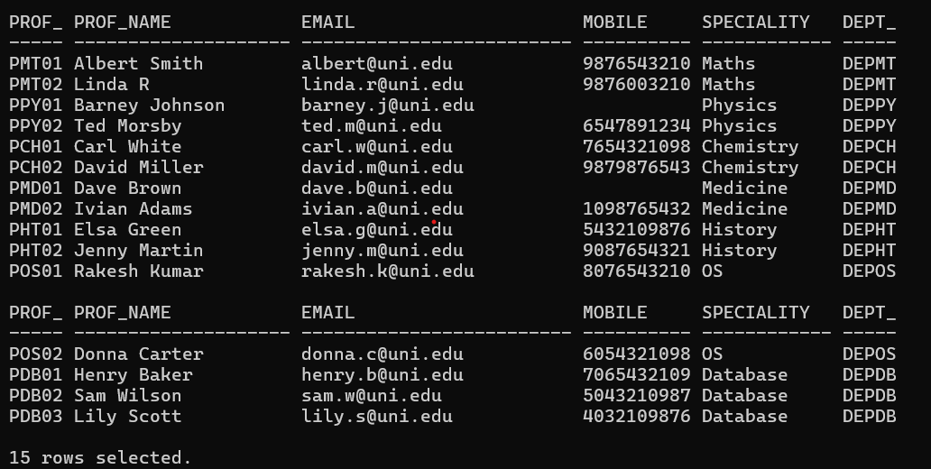

-- SCHOOL Table
select * from SCHOOL;
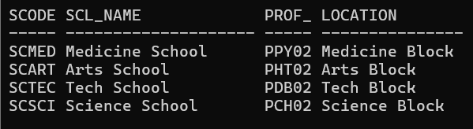

-- DEPARTMENT Table
select * from DEPARTMENT;
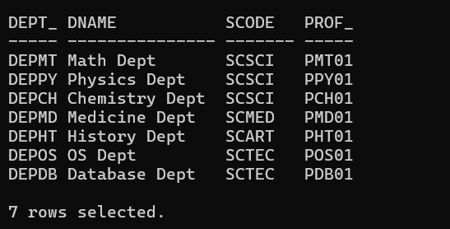

-- COURSE Table
select * from COURSE;
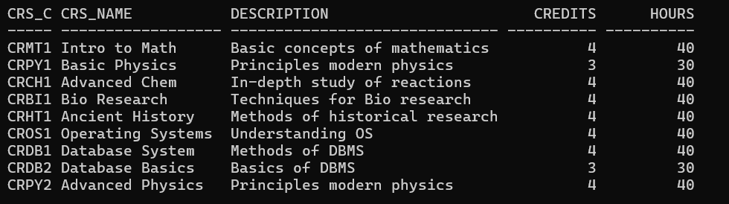

-- SEMESTER Table
select * from SEMESTER;
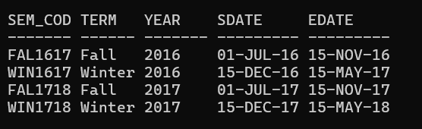

-- CLASS Table
select Cls_code, Slot, TO_CHAR(Stime, 'HH24:MI') AS Stime_HHMM, TO_CHAR(Etime, 'HH24:MI') AS Etime_HHMM, Crs_code, Prof_id, Room_no, Sem_code, Day_of_week, FROM CLASS;
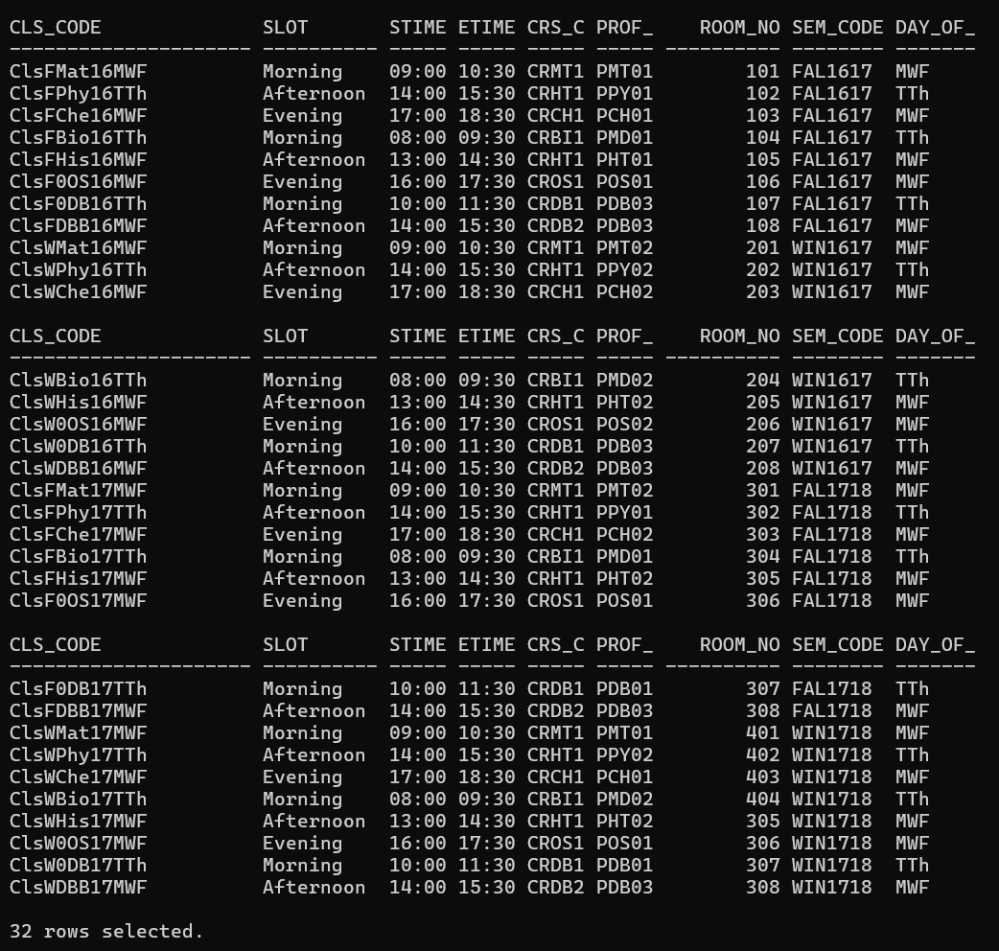

-- STUDENT Table
select * from STUDENT;
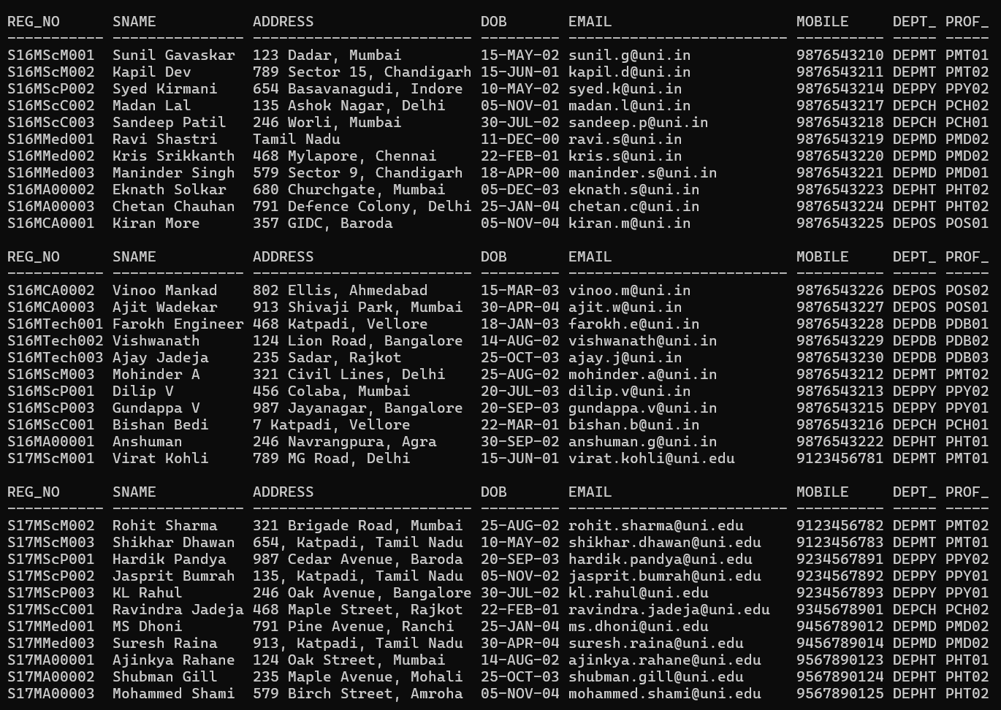
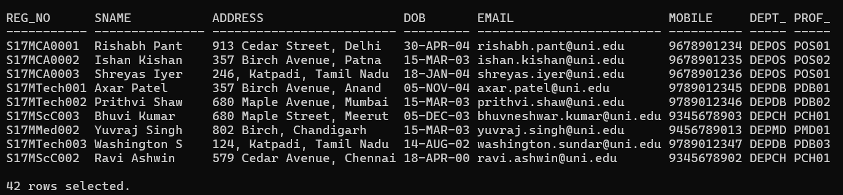

-- ENROLL Table
select Cls_code, Reg_no, TO_CHAR(Enroll_time, 'YYYY-MM-DD HH24:MI') AS Enroll_time, Grade FROM ENROLL;
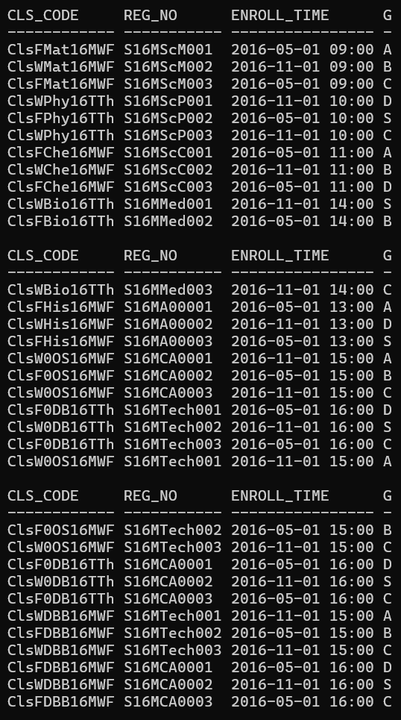
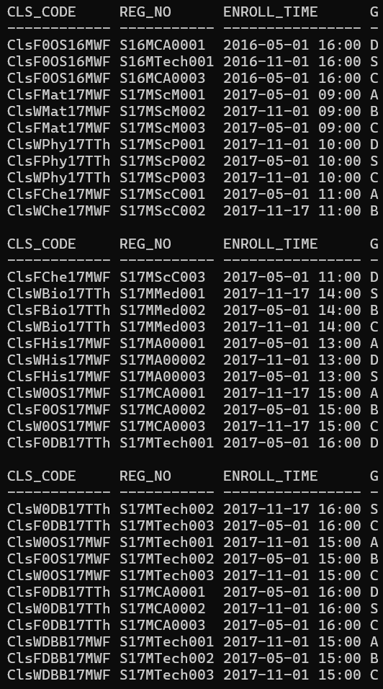
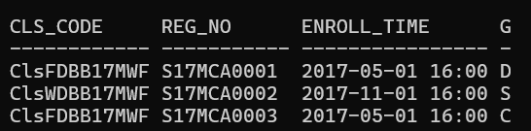

-- STUDENT_VISA Table
select * from STUDENT_VISA;
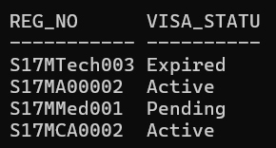

-- PROGRAMME Table
select * from PROGRAMME;
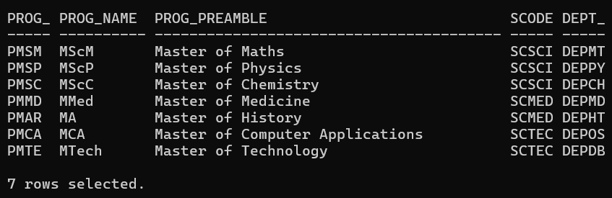

-- Q4.
--(i) Test the string manipulation functions – UPPER, LOWER, INITCAP, LENGTH, LPAD, RPAD, LTRIM, RTRIM and TRIM, using select queries on data present in the tables. Use one query each for demonstration of one function.
--UPPER
SELECT UPPER(Prof_Name) AS Uppercase_Name FROM PROFESSOR;
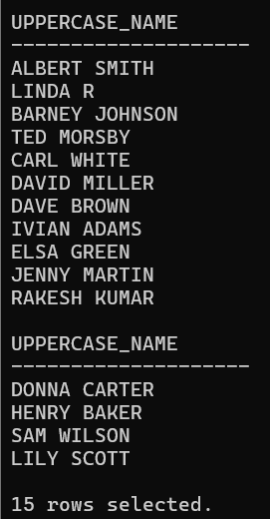

--LOWER
SELECT LOWER(Prof_Name) AS Lowercase_Name FROM PROFESSOR;
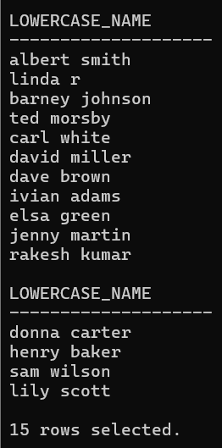
--INITCAP
SELECT INITCAP(Prof_Name) AS Initcap_Name FROM PROFESSOR;
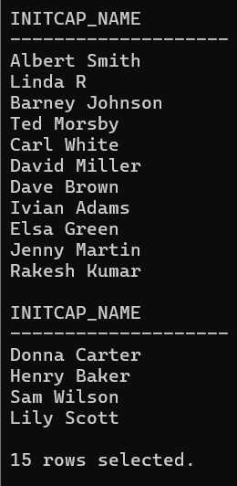

--LENGTH
SELECT Prof_Name, LENGTH(Prof_Name) AS Name_Length FROM PROFESSOR;
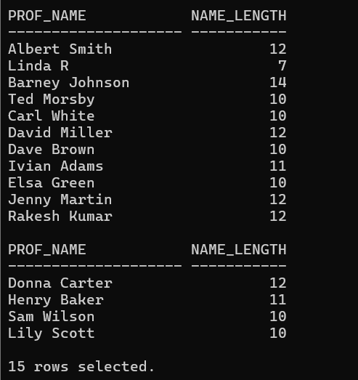

--LPAD
SELECT LPAD(Prof_Name, 15, '*') AS Lpad_Name FROM PROFESSOR;
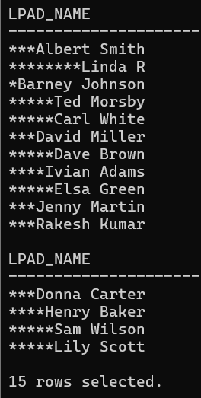

--RPAD
SELECT RPAD(Prof_Name, 15, '*') AS Rpad_Name FROM PROFESSOR;
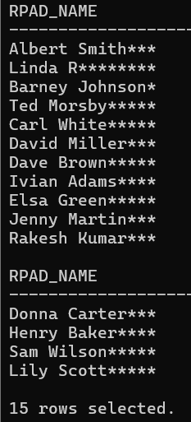

--LTRIM
SELECT LTRIM(Prof_Name, 'D') AS Ltrim_Name FROM PROFESSOR WHERE Prof_Name LIKE 'D%';
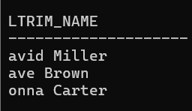

--RTRIM
SELECT RTRIM(Prof_Name, 'n') AS Rtrim_Name FROM PROFESSOR WHERE Prof_Name LIKE '%n';
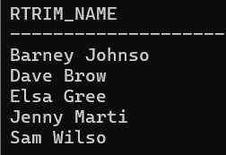
--TRIM
SELECT TRIM(' ' FROM Prof_Name) AS Trimmed_Name FROM PROFESSOR;
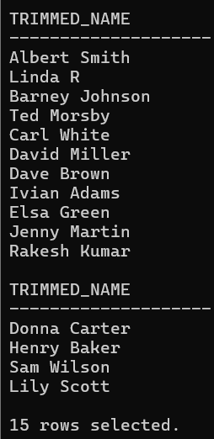

--(ii) Write query to illustrate usage of NVL function and NULLIF function.
--NVL function
SELECT Prof_id, NVL(Mobile, 'Not Provided') AS Mobile_Number FROM PROFESSOR;
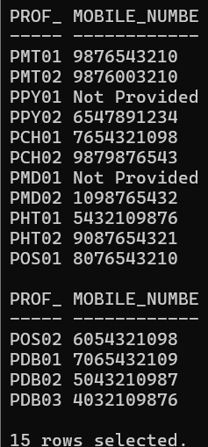

--NULLIF function
SELECT Cls_code, Slot, Day_of_week, NULLIF(Slot, Day_of_week) AS Slot_Check FROM CLASS;
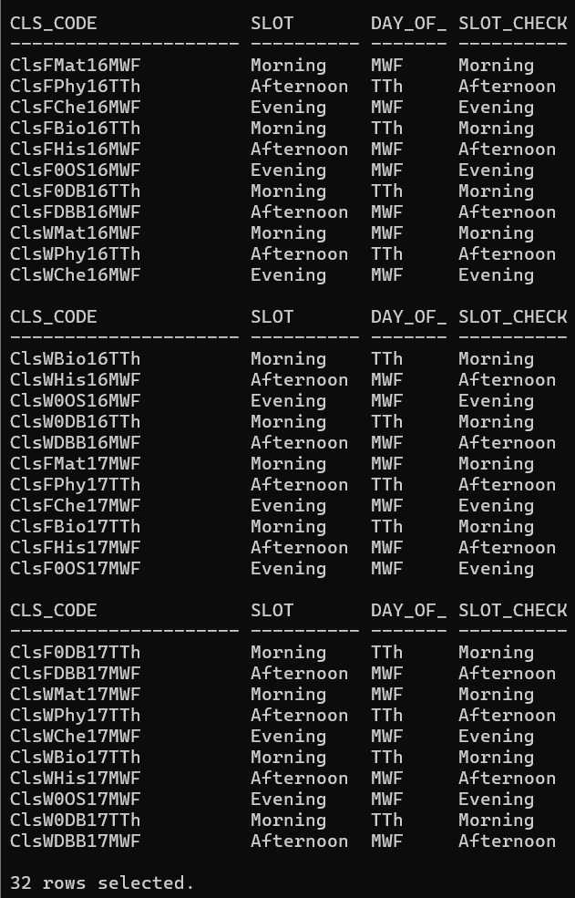

--(iii) Display the name of the students who were born on a specified month.
SELECT Sname FROM STUDENT WHERE TO_CHAR(DoB, 'MM') = '05';
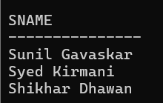

--(iv) Display the name of the students with a specified date of birth.
select Sname from STUDENT where DoB = TO_DATE('2004-01-25', 'YYYY-MM-DD');
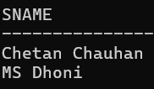

--(v) Display the date of birth of a specified student in the format ‘Day of week, Month dd, yyyy’.
SELECT Sname, TO_CHAR(DoB, 'Day, Month dd, yyyy') AS Formatted_DoB FROM STUDENT WHERE Sname = 'Virat Kohli';
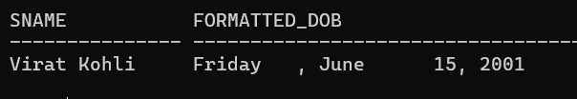

--(vi) Display the hour and minutes of the start time and end time of a specified slot.
SELECT Slot, TO_CHAR(Stime, 'HH24:MI') AS Start_Time_HHMM, TO_CHAR(Etime, 'HH24:MI') AS End_Time_HHMM FROM CLASS WHERE Slot = 'Morning' AND ROWNUM <= 5;
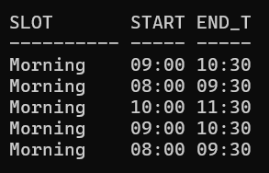

--(vii) Display the day of week of the start date and end date of Winter semester 17–18.
SELECT Sem_code, TO_CHAR(Sdate, 'Day') AS Start_Day, TO_CHAR(Edate, 'Day') AS End_Day, Year FROM SEMESTER WHERE Term = 'Winter' AND Year = '2017';

--(viii) Display the duration of Winter semester 17–18 in terms of number of weeks. || is used for string concatenation
SELECT Term, ROUND((Edate - Sdate) / 7)||' Weeks' AS Duration_in_Weeks, Year FROM SEMESTER WHERE Term = 'Winter' AND Year = '2017';
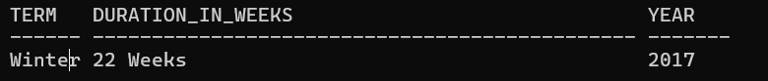
-- Q5.
--(i) Display name, email address and address for those students who live in Katpadi area and whose name has an ‘s’ as the third character.
select Sname, Email, Address from STUDENT where Address like '%Katpadi%' and Sname like '__s%';
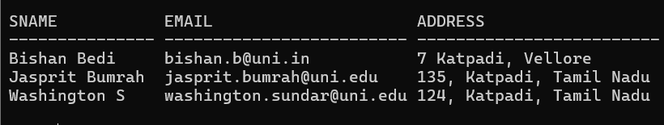

--(ii) Display name, email address and address for those students who are not from Tamil Nadu.
select Sname, Email, Address from STUDENT where Address like '%Tamil Nadu%';
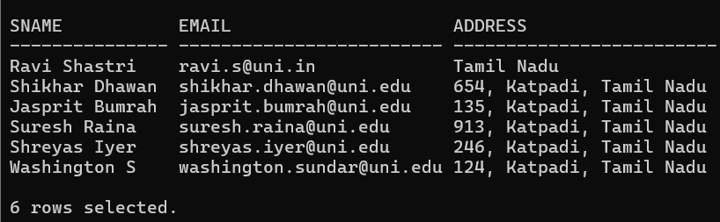

--(iii) Display name, email address and address of foreign students only.
SELECT S.Sname, S.Email, S.Address FROM STUDENT S INNER JOIN STUDENT_VISA SV ON S.Reg_no = SV.Reg_no;
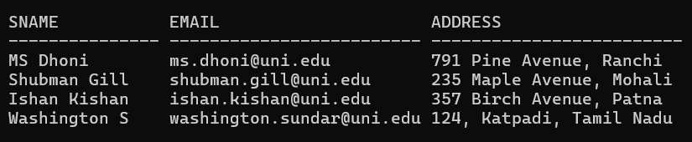

--(iv) List the name of professors along with their specialty who belong to School of Medicine.
SELECT P.Prof_id, P.Prof_name, P.Speciality FROM PROFESSOR P INNER JOIN DEPARTMENT D ON P.Dept_id = D.Dept_id INNER JOIN SCHOOL S ON D.SCode = S.SCode WHERE S.Scl_name = 'Medicine School';
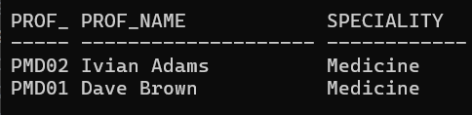

--(v) Display name of the school and name of professor who chairs the school.
select Scl_name, Prof_name from SCHOOL S, PROFESSOR P where S.Prof_id = P.Prof_id;
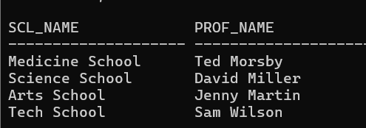

--(vi) List course code, course name and course description in alphabetic order of course code.
SELECT Crs_code, Crs_name, Description FROM COURSE ORDER BY Crs_code;
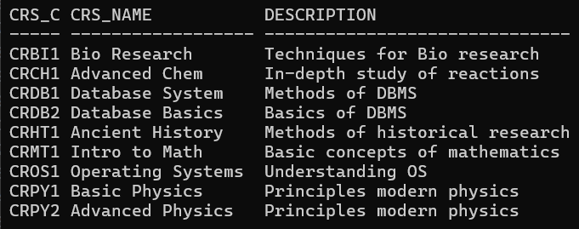

--(vii) Change the mobile number of a student interactively.
update STUDENT set Mobile= &Mobile where Reg_no='S17MScM001';
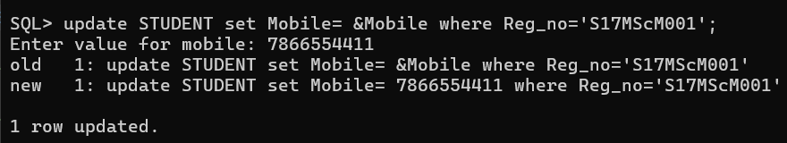

--(viii) Remove enrollment information of a student from a particular course interactively. How would you recover the data?

--(ix) Create a duplicate of course table.
create table copy_course as (select * from COURSE);
select * from copy_course;
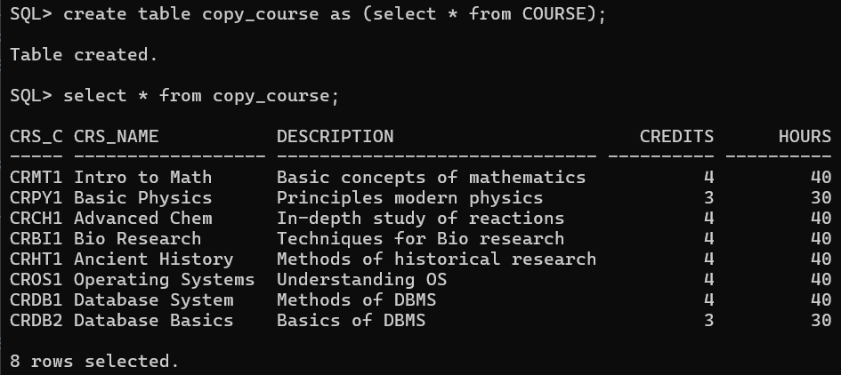

--(x) Create a view for list of students (Reg_no, Sname) and the courses they have registered along with name of professors teaching the course.
CREATE VIEW StudentCourseProfessor AS
SELECT S.Reg_no, S.Sname, C.Crs_name,
(SELECT P.Prof_name
FROM PROFESSOR P
WHERE P.Prof_id = CL.Prof_id) AS Professor_name
FROM
STUDENT S, ENROLL E, CLASS CL, COURSE C
WHERE
S.Reg_no = E.Reg_no
AND E.Cls_code = CL.Cls_code
AND CL.Crs_code = C.Crs_code;
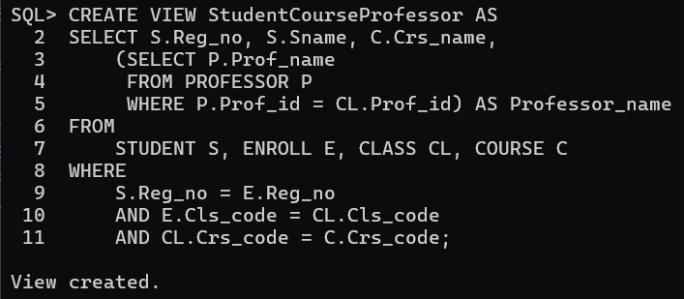

--(xi) List the room number, slot, start time, end time and duration of every class held on Wednesdays in descending order of room number.
SELECT Room_no, Slot, TO_CHAR(Stime, 'HH:MI') AS Start_time, TO_CHAR(Etime, 'HH:MI') AS End_time,
EXTRACT(HOUR FROM (Etime - Stime)) || ' hr ' || EXTRACT(MINUTE FROM (Etime - Stime)) || ' min' AS Duration
FROM Class WHERE Day_of_week LIKE '%W%' ORDER BY Room_no DESC;
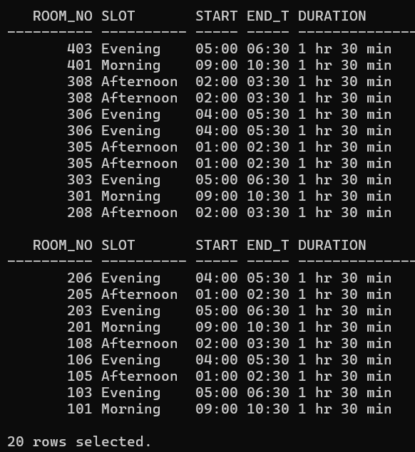

--(xii) Display the name and grade of a student in different courses underwent in fall semester 2017 – 18.
SELECT s.Sname, e.Grade
FROM STUDENT s, ENROLL e, CLASS cl, SEMESTER sem
WHERE s.Reg_no = e.Reg_no
AND e.Cls_code = cl.Cls_code
AND cl.Sem_code = sem.Sem_code
AND sem.Term= 'Fall'
AND sem.Year = '2017';
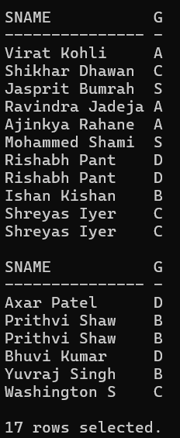

--(xiii) Find out name of students who have taken Database Systems course as well as Operating Systems course in fall semester 2016 – 17.
SELECT S.Sname
FROM STUDENT S, ENROLL E, CLASS CL, COURSE C, SEMESTER SEM
WHERE S.Reg_no = E.Reg_no
AND E.Cls_code = CL.Cls_code
AND CL.Crs_code = C.Crs_code
AND CL.Sem_code = SEM.Sem_code
AND SEM.Term = 'Fall'
AND SEM.Year LIKE '2016'
AND (C.Crs_name = 'Database System' OR C.Crs_name = 'Operating Systems')
GROUP BY S.Sname
HAVING COUNT(DISTINCT C.Crs_name) = 2;
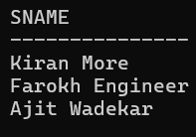

--(xiv) Find out name of students who have taken Database Systems course but have not taken Operating Systems course in winter semester 2017 – 18
SELECT s.Reg_no, Sname, e.Cls_code FROM STUDENT s, ENROLL e, CLASS cls, COURSE crs, SEMESTER sem
WHERE s.Reg_no = e.Reg_no
AND e.Cls_code = cls.Cls_code
AND cls.Crs_code = crs.Crs_code
AND cls.Sem_code = sem.Sem_code
AND sem. Term = 'Winter'
AND sem.Year LIKE '2017'
AND (crs.Crs_name LIKE 'Database System')
AND s.Reg_no NOT IN (
SELECT s2.Reg_no
FROM STUDENT s2, ENROLL e2, CLASS cls2, COURSE crs2, SEMESTER sem2
WHERE s2.Reg_no = e2.Reg_no
AND e2.Cls_code = cls2.Cls_code
AND cls2.Crs_code = crs2.Crs_code
AND cls2.Sem_code = sem2.Sem_code
AND sem2. Term = 'Winter'
AND sem2.Year LIKE '2017'
AND crs2.Crs_name LIKE 'Operating Systems%'
);
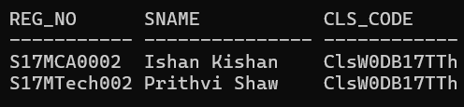

--(xv) List the registration number and name of the students who have registered for maximum number of credits in Winter 17-18 semester.
SELECT s.Reg_no, s.Sname, SUM(crs.Credits) AS Total_Credits
FROM STUDENT s, ENROLL e, CLASS cls, COURSE crs, SEMESTER sem
WHERE s.Reg_no = e.Reg_no
AND e.Cls_code = cls.Cls_code
AND cls.Crs_code = crs.Crs_code
AND cls.Sem_code = sem.Sem_code
AND sem. Term = 'Winter'
AND sem.Year LIKE '2017'
GROUP BY s.Reg_no, s.Sname
HAVING SUM(crs.Credits) = (
SELECT MAX(SUM(crs2.Credits))
FROM STUDENT s2, ENROLL e2, CLASS cls2, COURSE crs2, SEMESTER sem2
WHERE s2.Reg_no = e2.Reg_no
AND e2.Cls_code = cls2.Cls_code
AND cls2.Crs_code = crs2.Crs_code
AND cls2.Sem_code = sem2.Sem_code
AND sem2. Term = 'Winter'
AND sem2.Year LIKE '2017'
GROUP BY s2.Reg_no
);
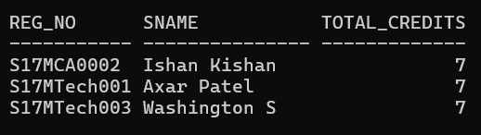

--(xvi) List the name of the course and the number of students registered in each slot for course under different faculty members.
SELECT c.Crs_name, cl.Slot, p.Prof_name, COUNT(e.Reg_no) AS No_of_Students
FROM COURSE c, CLASS cl, PROFESSOR p, ENROLL e
WHERE c.Crs_code = cl.Crs_code
AND cl.Prof_id = p.Prof_id
AND cl.Cls_code = e.Cls_code
GROUP BY c.Crs_name, cl.Slot, p.Prof_name
ORDER BY c.Crs_name, cl.Slot, p.Prof_name;
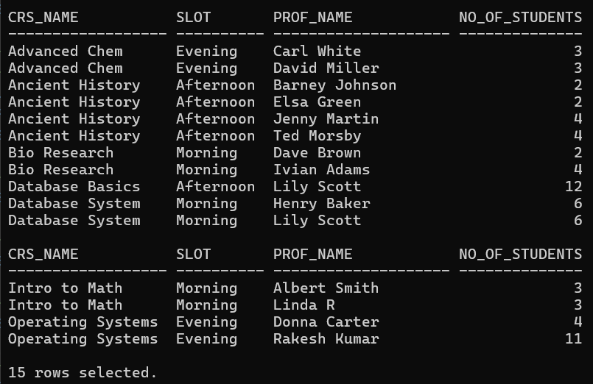

--(xvii) Find out the name of the students who have registered in all the courses being taught by Prof. OBrien in Winter 17-18.
SELECT S.Sname
FROM STUDENT S, ENROLL E, CLASS Cls, COURSE Crs, PROFESSOR P, SEMESTER Sem
WHERE S.Reg_no = E.Reg_no
AND E.Cls_code = Cls.Cls_code
AND Cls.Crs_code = Crs.Crs_code
AND Cls.Prof_id = P.Prof_id
AND Cls.Sem_code = Sem.Sem_code
AND Sem.Term = 'Winter'
AND Sem.Year LIKE '2017'
AND P.Prof_name LIKE 'Lily Scott'
GROUP BY S.Sname
HAVING COUNT(E.Cls_code) = (
SELECT COUNT(Cls.Cls_code)
FROM CLASS Cls, PROFESSOR P, SEMESTER Sem
WHERE Cls.Prof_id = P.Prof_id
AND Cls.Sem_code = Sem.Sem_code
AND Sem.Term = 'Winter'
AND Sem.Year LIKE '2017'
AND P.Prof_name LIKE 'Lily Scott'
);
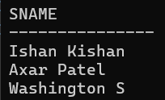

--(xviii) List the registration number of the students who registered in Database Systems course on November 17, 2017
select S.Reg_no from STUDENT S, ENROLL E, CLASS Cl, COURSE C
where
S. Reg_no = E.Reg_no and
E.Cls_code = Cl.Cls_code and
Cl.Crs_code = C.Crs_code
and
TO_CHAR(E.Enroll_time, 'YYYY-MM-DD') LIKE '2017-11-17' and
Crs_name = 'Database System';
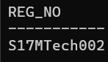

--(xix) Write a query to display the grade of a student given his/her registration number and the course name for Fall semester 17–18.
--S001
--Intro to Math
SELECT E.Grade
FROM ENROLL E, CLASS Cls, COURSE Crs, SEMESTER Sem
WHERE E.Cls_code = Cls.Cls_code
AND Cls.Crs_code = Crs.Crs_code
AND Cls.Sem_code = Sem.Sem_code
AND Sem.Term = 'Fall'
AND Sem.Year = '2017'
AND E.Reg_no = '&reg_no'
AND Crs.Crs_name = '&Crs_name';
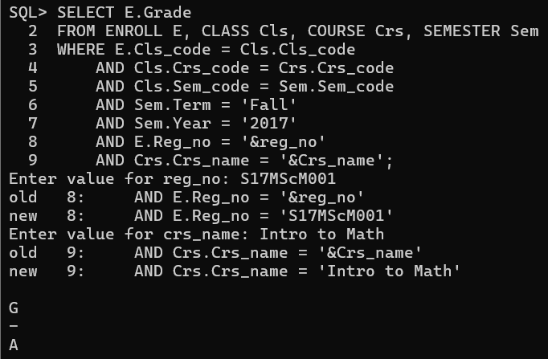

--(xx) List the name of departments and the name professors who is in charge of the department.
SELECT D.Dname, P.Prof_name FROM DEPARTMENT D, PROFESSOR P WHERE D.Prof_id = P.Prof_id;
--(xxi) List the name of schools with students’ strength higher than 7000.
SELECT S.Scl_name from SCHOOL S, STUDENT St, DEPARTMENT D
where
S.SCode = D.SCode and
St.Dept_id = D.Dept_id
group by
S.Scl_name
having
count(*) > 10;
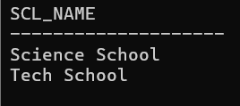

--(xxii) List the name of the department(s) under school of medicine with student strength higher than the average students of all the departments in the school.
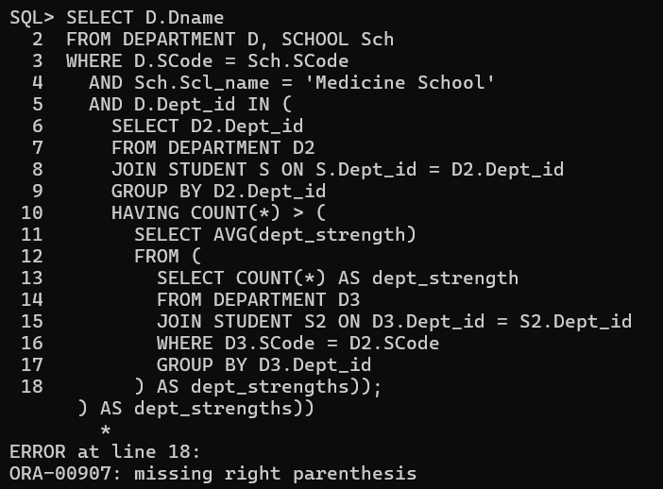

--xxiii) Given the registration number of a student, display the total credits registered by him/her in Winter 17–18.
select sum(Credits) from ENROLL E, CLASS Cl, COURSE C, SEMESTER S
where
E.Cls_code = Cl.Cls_code and
Cl.Crs_code = C.Crs_code and
Cl.Sem_code = S.Sem_code and
E.Reg_no = 'S17MTech001' and
S.Year = '2017' and
Term = 'Winter';
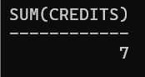

--(xxiv) Given the registration number of a student, display her/his grade in the course she/he registered in Fall 17–18.
select C.Crs_name, E.Grade from ENROLL E, CLASS Cl, COURSE C, SEMESTER S
where
E.Cls_code = Cl.Cls_code and
Cl.Crs_code = C.Crs_code and
Cl.Sem_code = S.Sem_code and
E.Reg_no = 'S17MCA0001' and
S.Year = '2017' and
S.Term = 'Fall';
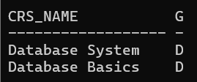

--(xxv) Display the name of the courses that are not being offered in Winter 17–18.
SELECT Crs_name
FROM COURSE
WHERE Crs_name NOT IN (
SELECT C.Crs_name
FROM COURSE C, CLASS Cl, SEMESTER S
WHERE
C.Crs_code = Cl.Crs_code
AND Cl.Sem_code = S.Sem_code
AND S.Year = '2017'
AND S.Term = 'Winter'
);
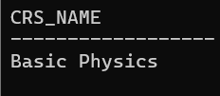

--(xxvi) Write necessary SQL statement to advance the start time and end time of every class by ten minutes in Fall 17-18.
UPDATE CLASS
SET
Stime = Stime + INTERVAL '10' MINUTE,
Etime = Etime + INTERVAL '10' MINUTE
WHERE
Cls_code IN (
SELECT Cl.Cls_code
FROM COURSE C, CLASS Cl, SEMESTER S
WHERE
C.Crs_code = Cl.Crs_code
AND Cl.Sem_code = S.Sem_code
AND S.Year = '2017'
AND S.Term = 'Fall'
);
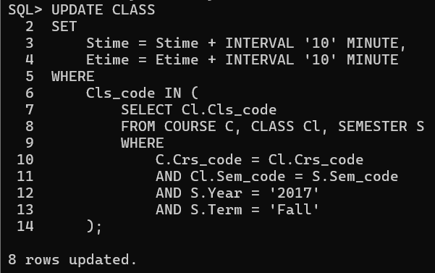

--(xxvii) Write necessary SQL statement to advance the start date and end date of Fall 16–17 semester by one week with respect to Fall semester of 17 – 18.
UPDATE SEMESTER
SET
Sdate = (SELECT Sdate + INTERVAL '7' DAY
FROM SEMESTER
WHERE Term = 'Fall' AND Year = '2017'),
Edate = (SELECT Edate + INTERVAL '7' DAY
FROM SEMESTER
WHERE Term = 'Fall' AND Year = '2017')
WHERE
Term = 'Fall'
AND Year = '2016';
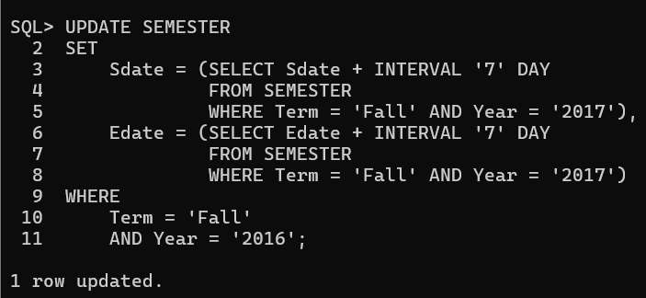

--(xxviii) Find out the name list of students who had secured ‘S’ grade in at least 50% of the courses cleared by her/him
SELECT S.Sname
FROM STUDENT S
WHERE
(SELECT COUNT(*)
FROM ENROLL E
WHERE E.Reg_no = S.Reg_no AND E.Grade = 'S') >=
(SELECT COUNT(*) / 2
FROM ENROLL E
WHERE E.Reg_no = S.Reg_no);
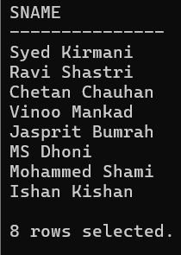

--(xxix) Given the registration number of a student, find out his/her free slots.
SELECT DISTINCT Cl.Slot
FROM CLASS Cl
WHERE Cl.Slot NOT IN (
SELECT C.Slot
FROM ENROLL E
JOIN CLASS C ON E.Cls_code = C.Cls_code
WHERE E.Reg_no = 'S17MScM003'
);
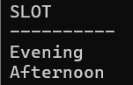

--(xxx) Find out the name list of students who have classes in the afternoon session only a specific day of the week.
SELECT S.Sname
FROM STUDENT S
WHERE NOT EXISTS (
SELECT 1
FROM ENROLL E
JOIN CLASS C ON E.Cls_code = C.Cls_code
WHERE E.Reg_no = S.Reg_no
AND C.Day_of_week LIKE '%W%'
AND C.Slot NOT LIKE 'Afternoon'
)
AND EXISTS (
SELECT 1
FROM ENROLL E
JOIN CLASS C ON E.Cls_code = C.Cls_code
WHERE E.Reg_no = S.Reg_no
AND C.Day_of_week LIKE '%W%'
AND C.Slot LIKE 'Afternoon'
);
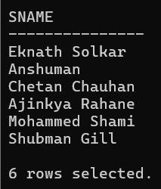

--(xxxi) Add a column named ‘Duration’ (to indicate duration of a class) with appropriate data type to the CLASS table and populate the column from values of start time and end time columns.
ALTER TABLE CLASS ADD Duration VARCHAR2(7);
UPDATE CLASS
SET Duration = TO_CHAR(EXTRACT(HOUR FROM (Etime - Stime)), 'FM00') || ':' ||
TO_CHAR(EXTRACT(MINUTE FROM (Etime - Stime)), 'FM00');
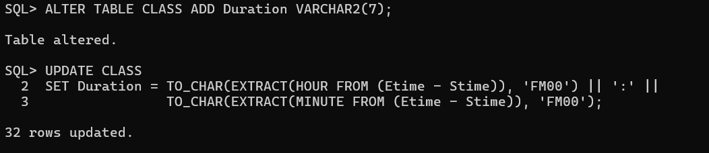

--(xxxii) Add a column named ‘SemesterDuration’ (indicating duration of a semester) with appropriate data type to the SEMESTER table and populate the column from values of start date and end date columns.
ALTER TABLE SEMESTER ADD SemesterDuration NUMBER(1);
UPDATE SEMESTER SET SemesterDuration = ROUND(MONTHS_BETWEEN(Edate, Sdate));
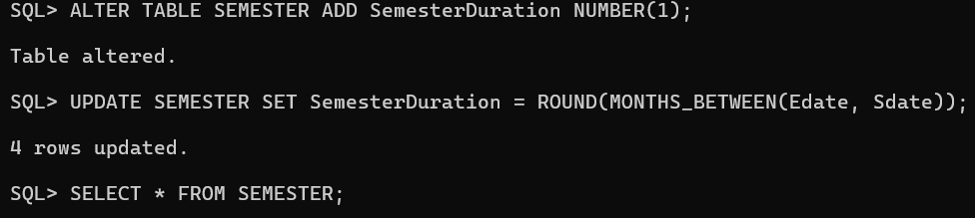

--(xxxiii) Find out the list of students who are undergoing MCA program.
SELECT S.Sname FROM STUDENT S, PROGRAMME P WHERE S.Dept_id = P.Dept_id AND P.Prog_name = 'MCA';
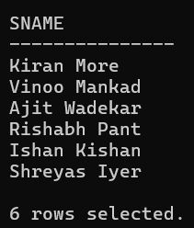

--(xxxiv) Display the name of programs and the name of school offering the program.
SELECT Prog_name, Scl_name FROM PROGRAMME P, SCHOOL S WHERE P.SCode = S.SCode;
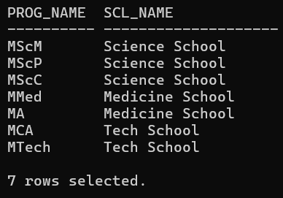

--(xxxv) Display the name of the departments and the name of the program controlled by the department.
SELECT Dname, Prog_name FROM DEPARTMENT D, PROGRAMME P WHERE D.Dept_id = P.Dept_id;
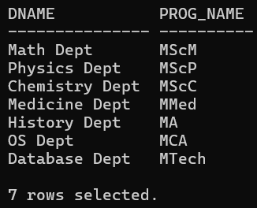

--(xxxvi) Find the school which has highest school strength (i.e number of students)
SELECT Scl_name
FROM (
SELECT Sch.Scl_name
FROM SCHOOL Sch
JOIN DEPARTMENT D ON Sch.SCode = D.SCode
JOIN STUDENT S ON D.Dept_id = S.Dept_id
GROUP BY Sch.Scl_name
ORDER BY COUNT(S.Reg_no) DESC
)
WHERE ROWNUM = 1;
